24th INTERNATIONAL JUNIORS
CHAMPIONS 2022
IN FREE STYLE, GRECO-ROMAN AND WOMAN WRESTLING TOURNAMENT
13-14-15 May,2022 • ANTALYA - TÜRKİYE

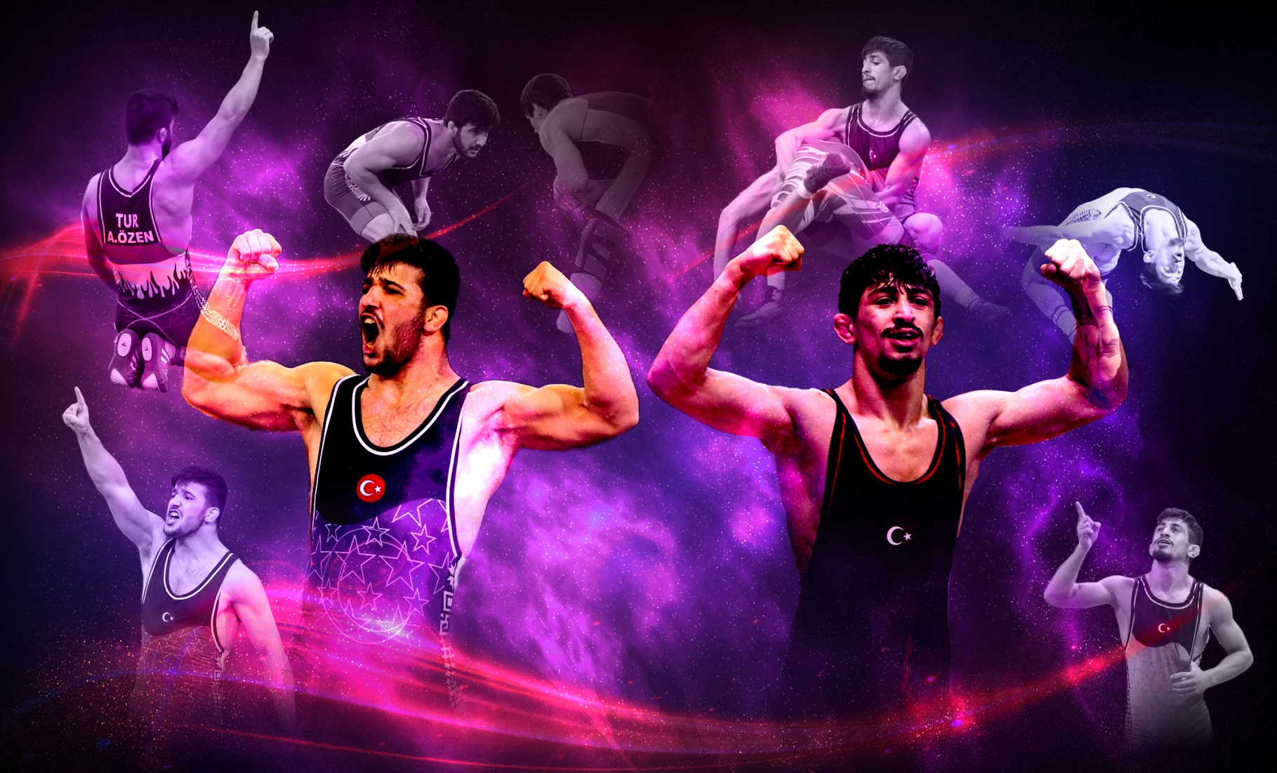

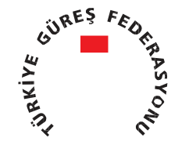

24th INTERNATIONAL JUNIORS
CHAMPIONS 2022

IN FREE STYLE, GRECO-ROMAN AND WOMAN WRESTLING TOURNAMENT

INVITATION TO

13-15 May 2022 • ANTALYA - TÜRKİYE

Dear President,

The 24th Edition of our Traditional International Juniors “Champions” Tournament in Free Style, Greco-Roman and Woman wrestling will be held on 13-15 May 2022 in ANTALYA / TURKİYE

INVITED COUNTRIES : Open Tournament For All Countries
**ALL PARTICIPANTS WILL HAVE TO PAY 60 EURO OR 70 USD PER DAY PER PERSON

Turkish wrestling Federations will provide from 12th of May, 2022 to 16th of May, 2022 local transfers (airport- hotel-hall) All delegations have to arrange their travels to the Antalya city.
The Tournament will take place in UWW Regulations on 3 mats recognized by UWW in the categories:

- Men FS : 57 – 61 – 65 – 70 – 74 – 79 – 86 – 92 – 97 - 125 kgs.
- Men GR : 55 – 60 – 63 – 67 – 72 – 77 – 82 – 87 – 97 - 130 kgs.
- Women : 50 – 53 – 55 – 57 – 59 – 62 – 65 – 68 – 72 - 76 kgs.
- Tolerance :First Day 1 Kg, Second Day 1 Kg

Final entries : before May 01, 2022
Medals and individual awards will be given to the winners.

*You can arrange your flight programme with www.thy.com.tr or www.onurair.com.tr,www.flypgs.com , www.izair.com.tr

Sincerely Yours,
Seref EROGLU
President of Turkey Wrestling Federation

12 May,2022 | Arrival of Delegations
 | 17:00-17:30 | Referee Clinic
 | 17:30-18:00 | Technical Meeting
 | 18:00-18:30 | DRAW All Categories
13 May,2022 | 08:00-08:30 | Weign –in (57-65-74-86-97Kg FS)&(55-63-72-82-97 Kg GR)&(50-55-59-65-72 Kg Womens)  Tolerans 1Kg
 | 10:00-13:00 | Eliminations
 | 13:00-15:00 | Lunch Time
 | 15:00-18:00 | Eliminations and ½ Finals
14 May,2022 | 08:00-08:15 | Weign-in(57-65-74-86-97Kg FS)&(55-63-72-82-97 Kg GR)&(50-55-59-65-72 Kg Womens) Tolerans 1Kg
 | 08:15-08:45 | Weign-in (61-70-79-92-125Kg FS)&( 60-67-77-87-130Kg GR)&( 53-57-62-68-76Kg Womens)Tolerans 1Kg
 | 10:00-13:00 | Repechage and Eliminations
 | 13:00-15:00 | Lunch Time
 | 15:00-18:00 | Eliminations and ½ Finals
 | 18:00-18:30 | Opening Ceronomy
 | 18:30-20:00 | Bronze and Gold medal matches (57-65-74-86-97Kg FS)&(55-63-72-82-97 Kg GR)&(50-55-59-65-72 Kg Womens)
15 May, 2022 | 08:45-09:00 | Weign-in (61-70-79-92-125Kg FS)&( 60-67-77-87-130Kg GR)&( 53-57-62-68-76Kg Womens) Tolerans 1Kg
 | 11:00-12:30 | Repechages
 | 12:30-15:30 | Bronze and Gold medal matches (61-70-79-92-125Kg FS)&( 60-67-77-87-130Kg GR)&( 53-57-62-68-76Kg Womens)
16 May, 2022 | Departure of Delegations (before 12:00 am)

